Two story building / 1100m²
• Built in 1969 reconstructed in 1998
• Two separate entrances to the building via staircases on both sides and elevator
• All communications
• Ceiling height to 3.6m
• Convenient driveway and separate entrance possible from Saltiniu Street

Floor #1
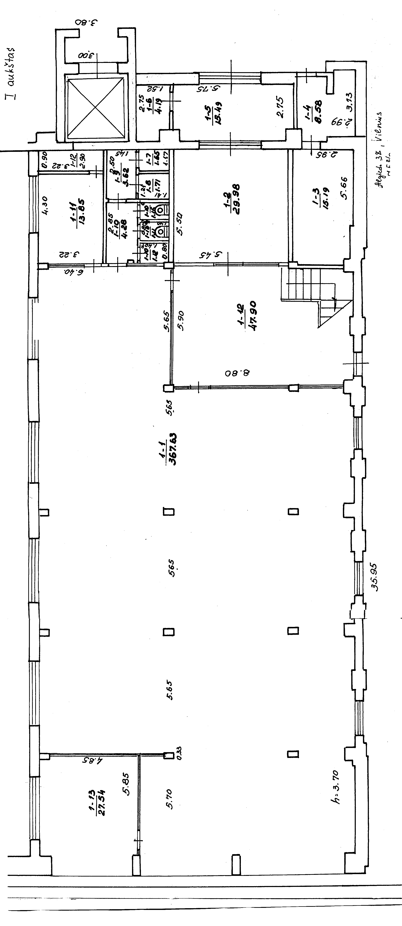

Floor #2

